CUBAN MISSILE CRISIS

I have followed with interest several e-mails relating to the movements of members of our organization during the Cuban Missile crisis. It seems that little information was shared with them at that time. My movements after 2 ½ years duty with the Presidential Protection Detail started with leaving from Camp David one night in early June to drive to the Naval Academy at Annapolis to join the Marine Corps top shooters as a weapons instructor for the Plebes during the summer.

In the first week of September 1962 I joined the 2nd Marine Division where I was immediately assigned to intelligence at Headquarters Battalion. During the month reports started coming in regarding Cuba culminating the weekend of 27/28 October, 1962 when the order to stand down was issued. The 2nd MarDiv was given orders to mount out on a Friday night (5th or 12th of October). On Sunday night a 6-By truck pulled into the HqBn parking lot with a mountain of unfolded and un-inventoried Top Secret material which included the Operation Plans, Communications Plans and Logistic Plans for the invasion of Cuba plus Arial Photographs and Maps of Cuba. All of this had been run off in a great hurry while convoys of trucks and other equipment were driving to Moorhead City.

I received the material which was both urgent and highly classified. No one in the chain of command was reachable so I commandeered about ten Marines, got them armed plus about 15 mount out boxes and two CH-34 Sea Hawks and crews which landed in the parking lot. Everything was piled into the crates and loaded onto the Sea Hawks with guards and ordered to fly to the Boxer (LPH-4) which was still at the wharf and due to sail at first light. No one of any rank questioned my orders from that night until the job was done Thursday night.

My Field Safe, 782 gear, .45 1911, Model 70 Winchester Snipers rifle and a Short Wave radio were thrown into a Third Truck and we drove to Moorhead City. The Driver had been driving since Friday and kept falling asleep at the wheel. A Mechanical Mule with a 105mm Recoilless Rifle was driving in front of us and I had to keep slapping the driver full in the face to keep him awake and to prevent him running over the Mule. We finally came to an MP stop with hot black coffee and made it the rest of the way to the dock. I looked up to the flight deck and saw my Boxes and Sentries dutifully protecting them. I boarded and ordered the boxes taken to the hanger deck and while doing this saw a Heavy Guided Missile Cruiser across the Quay put out to sea. Disregarding normal procedures the Ship had no tugs, went to flank speed at the dock with the helm put hard to Starboard and the engines were so strong that the propeller cavitations placed the Fan Tail below water level with the Ship healed far to Port. The sight of this brought home the urgency of the situation.

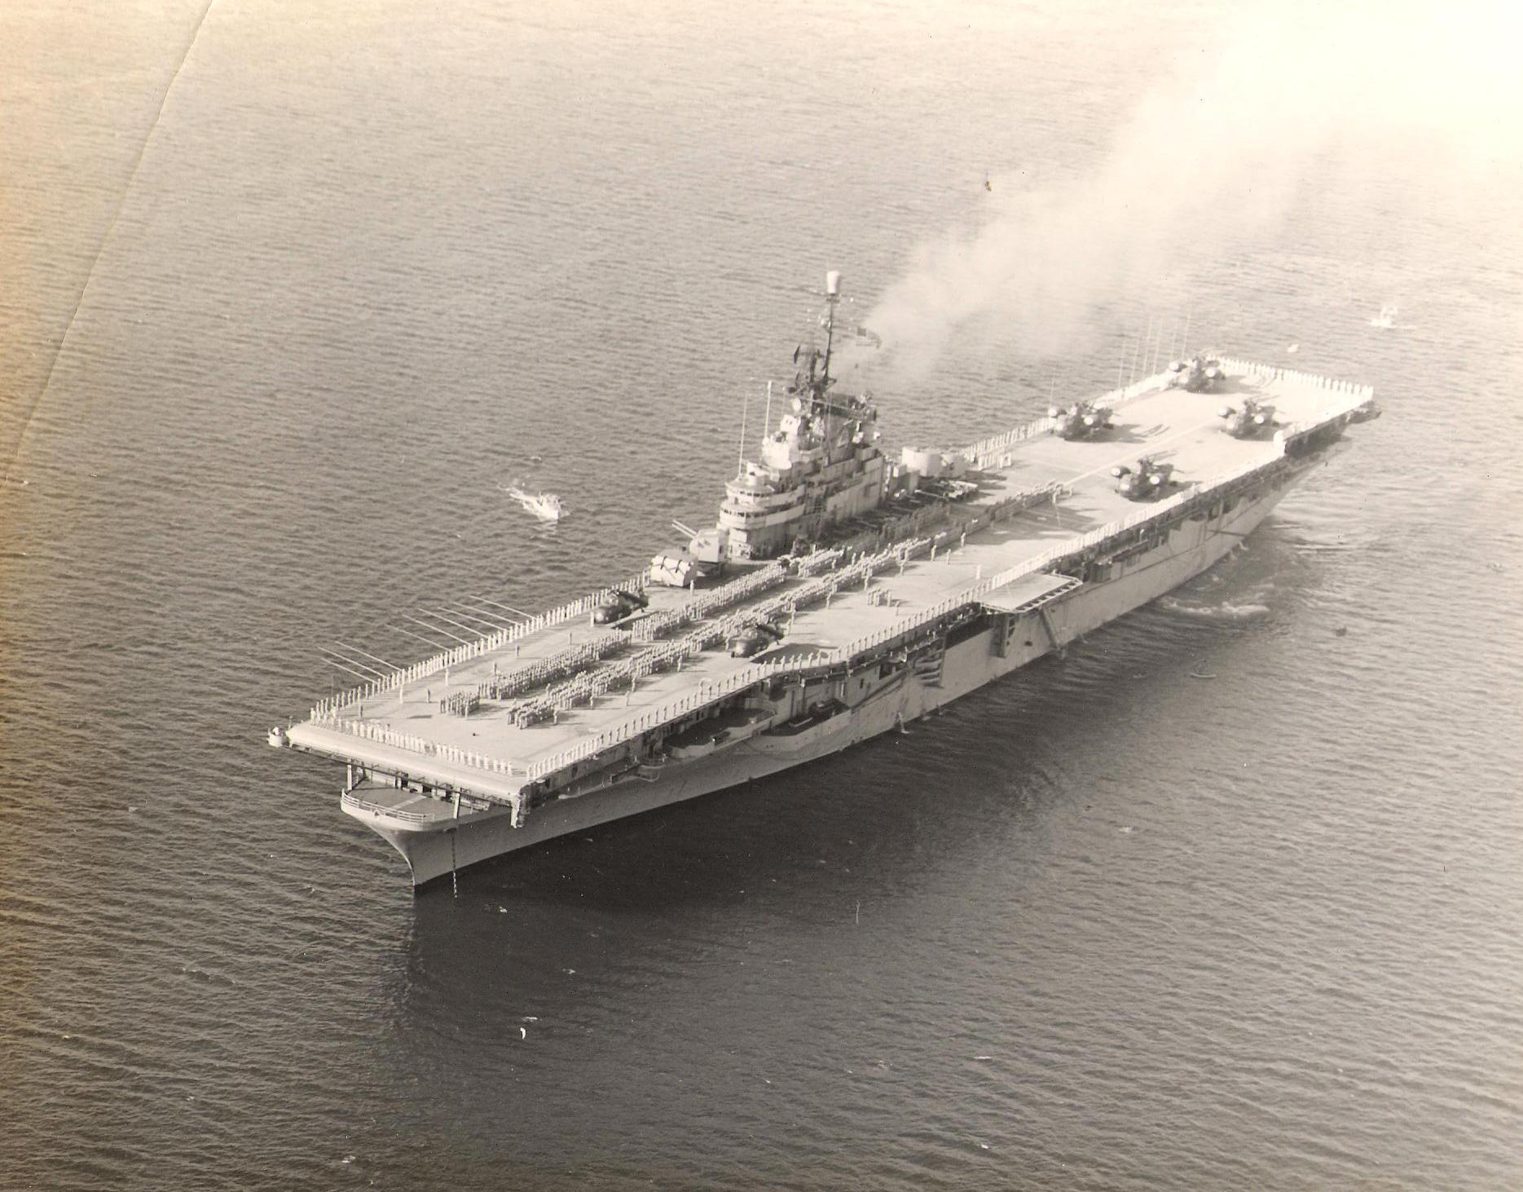

USS BOXER LPH-4

We sailed shortly after and we set up shop on the Hanger Deck aft. I used a bull horn to start the process of sorting out sets and inventorying them for dissemination to the Division Troop Commanders etc. When we cleared the Harbor and were at Sea, the ships loud speaker sounded “Set Condition Yoke”. Not knowing what that that meant I saw a number of sailors run up and open the Hanger Doors. The wind swept in sending classified documents out the starboard Hangar Door and onto the Ocean (we were making over 30 Knots). I sent Marines with fixed bayonets to reclose the Doors and with orders to bayonet anyone trying to open them (Marines love orders like that!). I saw several perplexed Sailors standing there beyond reach and then several Navy Officers trying to argue and then just going away. No more problems after that. The sets (a few incomplete and so marked) were finally sorted and inventoried and then “high-lined” to other ships. Thereafter I spent my time taking classified traffic to troop commanders in “Officer Country” near the ships brig where my boss, CWO-4 Harry L. Brooks and the CG, 2nd Mar Div (The two of them really ran the Division) could be found. My quarters were in the Parachute Loft between the Flight Deck and the Hanger Deck just aft of the 5” Gun Turrets on the Starboard side.

The Boxer had 2nd Force Recon, Pathfinders, ANGLICO, and much of the 6th Marines aboard. My quarters opened out onto a catwalk so I had a great view of other elements of the fleet as they formed. For the first time 4 LPH’s were operating together, the Boxer, the Iwo Jima, the Okinawa and the Thetis Bay. There were APA's, LST’s, AKA’s, APA’s, Destroyers, Destroyer Escorts and other types. Later there was a small Russian Spy trawler that stuck to us even through the Class 5 Hurricane eye. At one point I counted 64 ships visible at one time. I had a great opportunity to see how they took rough seas. On one occasion the AGC-7 Mount McKinley came alongside and I could see Jerry Curtis from 8th & I standing at the rail with one foot up on the rail (Jerry was with me at ITR Camp Geiger before the DC assignment).

I saw 2 Aircraft accidents in 37 days at sea, one was a 2 seat Kaman Observation Helicopter that could not take off, drifted to starboard and settled into the Ocean. Its 2 Blades interlaced at an angle and one clipped the edge of the deck hitting a seaman’s foot almost severing it. I heard that they had to amputate later that day. The Pilot came up to the surface mid-ship and the observer by the Fan Tail. A second was a Cargo Helicopter on fire that was burning coming from over the Horizon until it hit the deck smashing the under carriage. Although the Helicopter was chained to the Flight Deck right above my compartment the Storm snapped the chains and washed it away without a sound. The speed and angle it hit during the crash said that the Pilot almost did not make it back.

Ammunition was short as two Ammo ships had just returned from Vegas where there had had live fire exercises. I believe that we had only two bandoleers of ammo per man for the first wave only. External Cargos of Trench .12 ga. shotguns were flown in with brass casing shells. All the Blood Banks on the east coast were emptied out of excess whole blood which stocks were later dumped at sea when their shelf life expired. An elderly Red Cross representative was flown aboard only to suffer a heart attack and die while leaving the chopper. His body was stored in a meat reefer.

By the time the start of hostilities was to begin, Soviet surface to surface missile systems had locked in on the Boxer (the quarantine line was 500 miles off Cuba). Thanks to Secretary of Defense Robert McNamara, all 20mm and 40mm weapons had been eliminated from the Boxer as no longer needed. He did the same thing with .50 Cal ground mounted machine guns and the 2nd Mar Div responded by hiding there weapons as they knew that they must have them. One day before an IG I remember a long line of marines carrying our .50’s out the gate to a state National Guard Armory to be hidden until inspectors left. We had ours on the Boxer and we planned to shoot down Soviet Missiles with a firing line on the deck of small arms, .50’s etc. The twin 5” guns were to fire into the water in front of the missiles to create water spouts to disrupt their guidance systems. We did not know until years later that the missiles were nuclear tipped.

During October a U-2 was shot down by a missile, at least one Navy F-8 Crusader flying at 350 feet at 350 knots was shot down and I believe 2 Air Force RF 101
Voo-Doo Supersonic Photo Recon Jets were shot down on low level runs by self-propelled ZSM 23 mm radar equipped guns.

On the night of October 27th, at last light, I was ordered to assist 2nd Force Recon Pathfinder Teams in boarding Seahawk Helicopters for a nighttime insertion into the Mountains in Cuba. The first parachute drop from a Seahawk had only been done a year earlier in daylight. The men were so heavily loaded that they could not easily mount the wood steps to enter and I assisted each one and spoke to several. They were carrying Parachutes, Weapons, Ammunition, Packs, Marker Panels, Radios and other equipment to guide in the 82nd and 101 Airborne Divisions in their jumps. Their job was to keep the radio markers working no matter what. When they failed to return to the ship after the stand down was ordered early on the 28th, I feared the worst. Years later when I worked at senior levels on National Security matters I asked Under Secretary of State Bill Schneider if they were ever recovered and he said no. I then thought about recovering their remains and in that effort had conversations with the Force Recon Assn. and found out not only that I had been given incorrect information by the Under Secretary but then spoke directly to one of the guys I helped board. The Pathfinders first stick jumped that night and the recall code came in right after. Somehow they recovered the fist stick and instead of returning to the Boxer were redirected to the USS Randolph, CV-15.

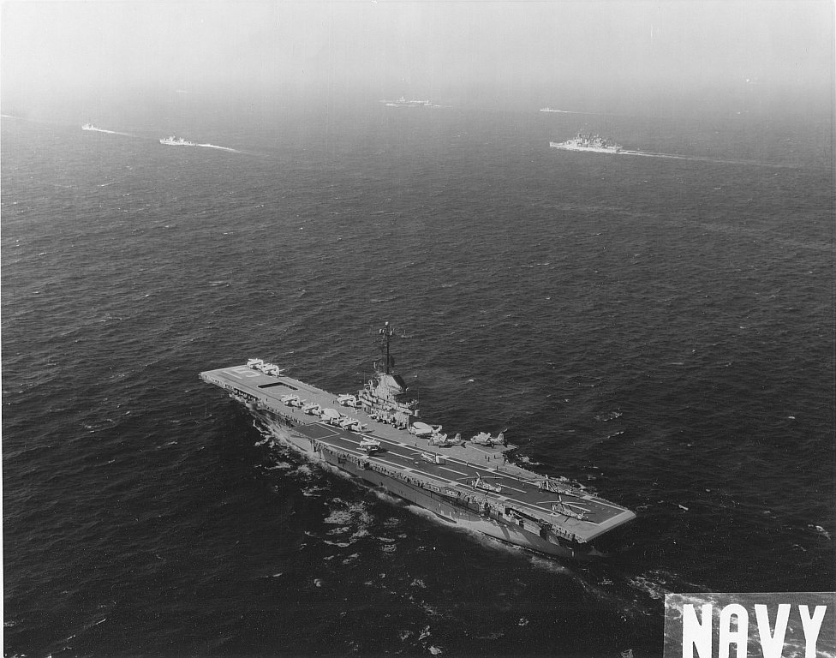

USS Randolph

Marines in Gitmo would not have had a dull time (classified, I can’t reveal details) in fact the 1st and 2nd Marine Divisions would be very busy. I listened to Radio Havana and they continually broadcast that graves were reported being dug behind Sugar Cane Factory 12 etc. for American Marines and Paratroopers. They would then play music and then repeat the bogus reports. You knew they were rattled because they never changed the music record. It was “That Old Black Magic” by Frank Sinatra played over and over! Years later I knew an officer of the Brigade at the Bay of Pigs who was captive in Havana during this period. The prison had been wired for demolition by Castro and he planned on blowing it up when we went in. Friendly Guards had cut the demo cords to prevent this. He later served bravely in ASIA for the US. Years later I met a man at the Thai Embassy in DC at a reception. He had been one of Castro’s officers in overthrowing Batista and said that they had no idea that he was a Marxist. When he won, he immediately executed some of his own officers who he knew would not support his Marxist ideals (some by his own hand). He put some others including my new friend on probation. He said that by the time of the Missile Crisis they had become disillusioned with Castro (He had installed the informer system on every block and not even aspirin was to be had) and he went to Spain and defected to the US. He felt that the resistance had we gone in would have been minimal from Cubans at that time. He was head of Latin America for Coca Cola when I met him and rose to be Chairman and CEO of Coke.

We can all thank the Russian Political Officer aboard the Russian submarine we forced to surface for preventing its Capitan from firing a nuclear tipped torpedo at our ships which he was determined to do. Once again we are gravely threatened with Iranian and North Korean nuclear aspirations with unleashed Atomic attack and I hope we can remember how close we came in October of 1962 over 50 years ago.

Gordon Ferrie (L/Cpl)

