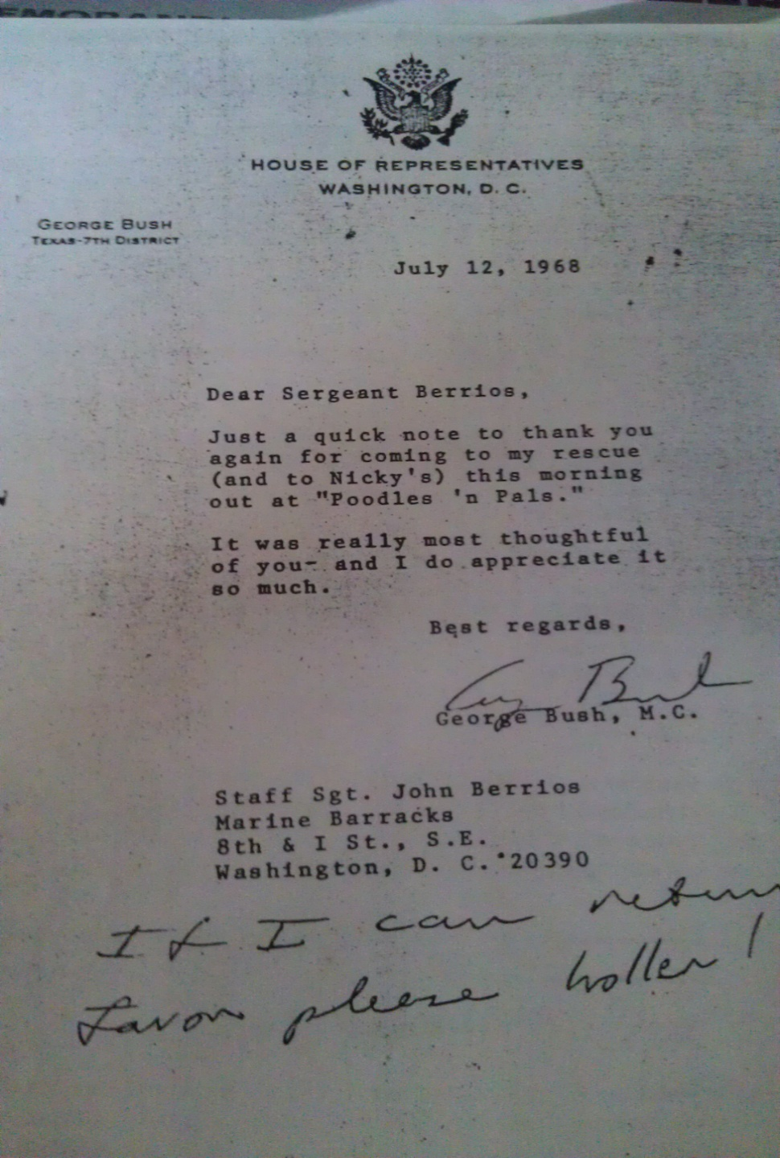

Good morning Ms. Wolfe. During my 4 yr tour at The Barracks I retained many memorable experiences and met outstanding men & woman, from private to a future President…An experience that stands out after 40 + yrs, like it was yesterday, happened in July 1968… I was on my way to rehearsal at the Iwo Jima Memorial, I was running early and made a stop in Georgetown…while waiting for the vendor to open, a gentleman arrived, also early, we made introductions and started conversation…I notice the gentleman looking at his wristwatch…I finally asked if he needed to depart that I would care for his business…He departed, vendor arrive, I took care of our business and proceeded to Iwo Jima Memorial. Arriving at the Barracks after rehearsals, I was informed that the Barracks CO, Colonel Joseph C. Fegan wanted to see me. That was the longest walk ever to his office.
I arrived, reported in, he was seated and started standing and standing, he was 6’5”. He came over placed his hand on my shoulder and thank me for making the Barracks proud…He could tell by my eyes that I didn’t know what he was talking about. He shared that he had lunch at the Capital with a US Representative and had shared with him meeting a Marine from his Command and what transpire that morning…The Colonel thank me again, as I was walking out of his office he call me back and share these words: Remember what I’m telling you today, this gentleman will be President of the U.S. His name: George H.W. Bush, 41st President of the United State.

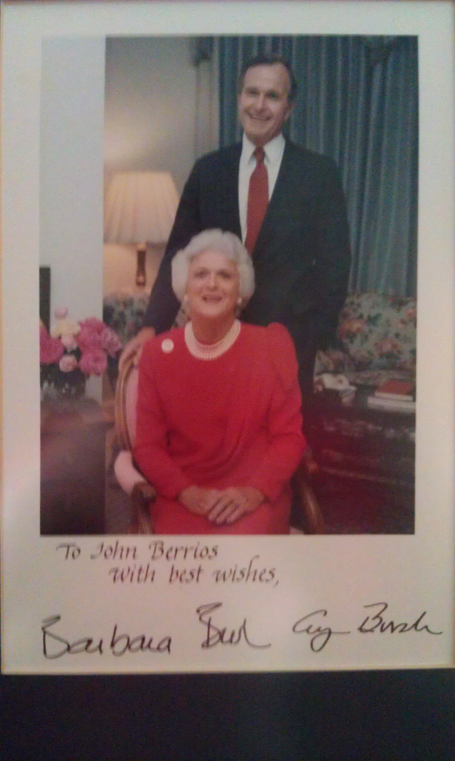
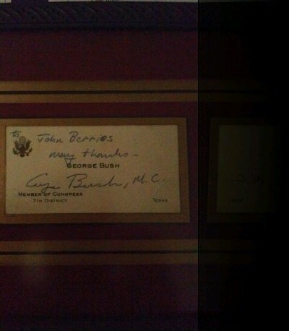
A memorable moment of a kind and caring BEING!!
Yours sincerely, I. John Berrios

